St Lawrence College, School of Business
Graduate Certificate Program, Business Analytics
ADMN5003: Data Acquisition, Analysis and Modelling Techniques (Fall 2022)
12 Marks
- Open book assignment to be completed independently or in a group of 2 students
- Submit a R file on BlackBoard in the portal of “Assignment 5”. Name it as “assign5R_First name1_First name2”. Write all your answers and coding in the same file. Clearly label question numbers.
- Late submission penalty is 10% per day.
__________________________________________________________________________________

- With the given pivot tables, compute probabilities for a) b) c) and d) by using the Naive Bayes method. Please provide detailed calculation such as (axb)x(cxd)x(exf) / [ (gxJ) + (kxt)] etc. (Total 2 marks, 0.5 mark each)
Pivot Table of flight status against weather
Row Labels | Bad | Good | Grand Total
Delayed | 32 | 396 | 428
Ontime | 1 | 1773 | 1774
Grand total | 33 | 2169 | 2202
Pivot Table of flight status against destination
Row Labels | EWR | JFK | Grand Total
Delayed | 267 | 161 | 428
Ontime | 915 | 859 | 1774
Grand Total | 1182 | 1020 | 2202

- P(Delayed|Weather=Good, Destination=EWR) =?
- P(Delayed|Weather=Good, Destination=JFK) = ?
- P(Delayed|Weather=Bad, Destination=EWR) = ?
- P(Delayed|Weather=Bad, Destination=JFK) = ?

- Association Rules. Question 14.2 (The Green Book, page 352). (Total 1 mark)
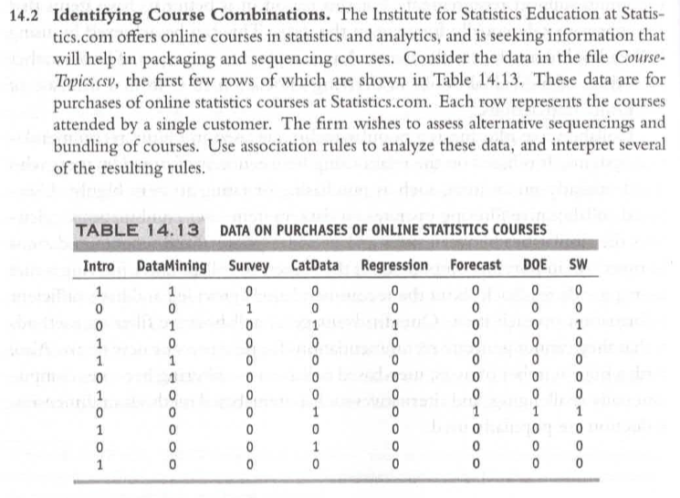
Run association rules on the data, with supp= 0.01, conf = 0.5. (0.5 mark) Interpret the top 3 association rules. Use the function inspect(sort(rules, by = "lift")) to sort resulting rules by lift. (0.5 mark)

- Using the dataset “Cereals.csv” to answer following questions on clustering. (4 marks)
- Remove all cereals with missing values. (0.5 mark) Normalize all predictor variables. (0.5 mark)
- Apply hierarchical clustering to the data using Euclidean distance. (1 mark) Show the clustering results from complete linkage with 5 clusters. (0.5 mark)
- Use K-means clustering with 5 clusters. (1 mark)
- Compare the results from b and c. (Hint: exam cluster members, and compute mean for each cluster) Discuss your results. (0.5 mark)

4. Use the “assign2data.csv” data you created in Assignment 2 to answer the following questions. (Total 5 marks) Note: this dataset has the missing values replaced with the median values, and has the outlier removed. The sample size is 24.
- Prepare your data (1 mark):
  - Transform a continuous variable into a categorical variable, or a categorical variable to continuous variable if necessary. Add an additional column for the transformed data.
  - Normalize your predictor variables if necessary.
  - Partition your data and use 60% training data for your analyses.
  - Choose the appropriate columns for your analyses.
- Use two of the supervised-learning data mining methods (2 marks)
- One method to analyze continuous output variable. Do not choose multiple linear regression for this, as you have used it in Assignment 2.
- Another method to analyze categorical output variable. Note: Your output variable is continuous, therefore you need to transform it to categorical in Step 1).
- Use the two predictor variables: one continuous and one categorical. Transform the data type, if necessary, in Step 1).
- Plot the result if you use neural network.
- Briefly describe the relationships between the two predictor variables and the output variable. For example, write the equation for logistic regression, describe the meaning of the best k and the identify the corresponding neighbors for k-NN, plot the best network for neural network, etc.
- What are the similarities and differences in the results of the two analyses? (simple descriptions are needed here)
- Do a performance analysis for each above method using the 40% validation data (2 marks)
- Use either residual comparisons or a lift chart/decile lift chart for method a)-continuous output variable.
- User either a confusion matrix or a lift chart/decile lift chart for method b)-categorical output variable.
- How is the performance of your models? Is there any overfitting?
- Among the two methods used, which one is better fitted to your data? Why? (simple descriptions are needed here)
- If your sample size increase from 24 to 2400, will you choose a different analytical method? Why? (simple descriptions are needed here)

